Advanced Complex Rag Workflow
https://github.com/mistralai/cookbook/tree/main/third_party/langchain
https://www.youtube.com/watch?v=sgnrL7yo1TE
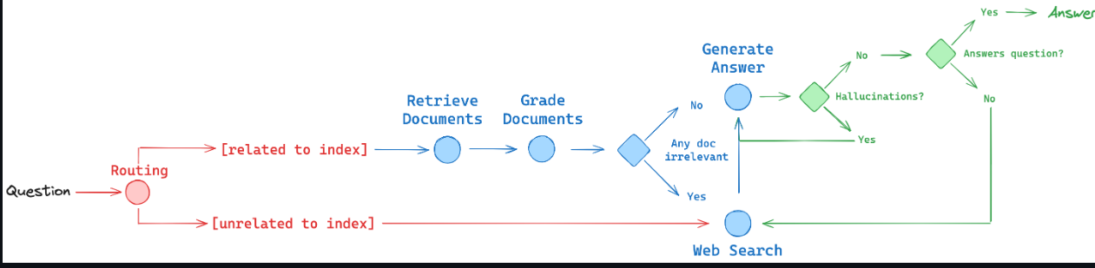
It's based on three papers research papers, Self Rag, Corrective Rag, and Adaptive Rag. The general idea of those papers is to add reflection into our workflow.
So, we want to reflect on the documents that we retrieve and to see if they are indeed correct for us or not (in the grade documents). If documents retrieved are not enough, we want to curate those documents and add new information from web search. (till blue part). After that, (green part) we also want to reflect on the answer. So we want to check if the answer is indeed grounded in the documents, and that the answer indeed answers the question.
And also there is a routing element where we're going to route our request to the correct data store that is going to have the information for our answer. (red part)

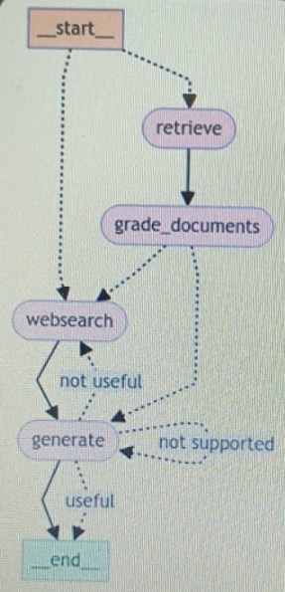

Corrective RAG
- This is an advanced react technique that is going to help us get more quality answers when performing retrieval, augmentation, generation.
- 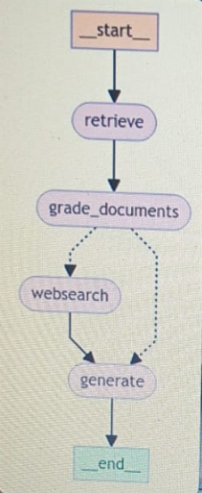
- We first want to start by taking our query performing in the vector-semantic-search and retrieving relevant documents from our vector store. After we have all those documents, we want to start and self-reflect, to critique those documents and to determine whether they are indeed relevant to our original query or not.
- If all of the documents are relevant to our query, then this is a happy flow and we simply want to augment our original prompt and send everything to the LLM like we always do in RAG.
- However, if you find document that we find out that are not relevant to our query, of course we want to filter the null and we also want to perform some external search on the internet and get to more information. And to augment our prompt with that real time information we get from online. And after we have that, we can augment our prompt and send everything to the LLM.
- And this technique is going to give us much more quality response.

